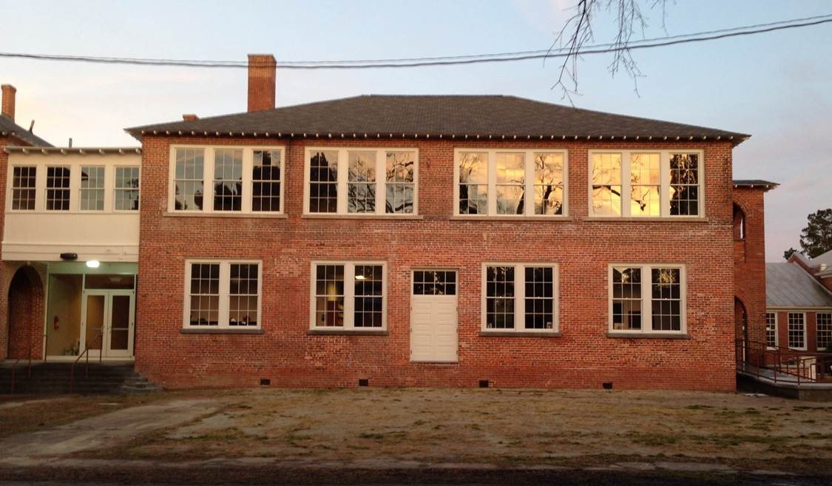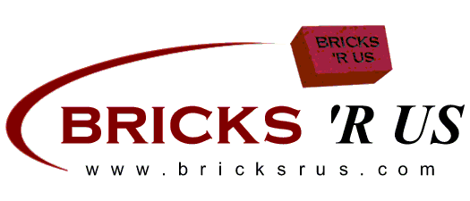

**BHS Preservation, Pirates and People are “Paving the Way”**



We are launching our engraved brick campaign to raise money to continue restoration of the Bath High School campus buildings. Commemorate a special event in someone's life, honor a friend or family member or memorialize someone special. We want the community, friends, alumni, and corporate and individual donors to join in this endeavor. It is very exciting because the end result will be a visible and everlasting tribute to the former Bath High School campus, the community and all of our supporters and donors. During the initial phase, the bricks will be placed along the central corridor entrance on Harding Street, construction schedule permitting. Each 4x 8 will have space for up to 3 lines and up to 18 characters per line and each 8"x 8" brick will have space for up to 6 lines and up to 18 characters per line. Bricks are red, smooth surface with beveled edges and will be laser engraved in all capital letters (filled black). You also have the option of purchasing a commemorative brick for display in your office or home and a donor recognition certificate.

**The cost of each 4"x8" brick is $75.00 and 8"x8" brick is $150.00.**

**If you would like a felt backed commemorative donor brick to display in your home or office as a**

**reminder of your contribution the cost for that is $30.00 for the 4x8 and $55.00 for the 8x8.**

- - - - - - - - - - - - - - - - - - - - - - - - - - -

Yes, we would like to reserve a permanent brick. Please engrave our brick as follows:

**ANY SYMBOL IS CONSIDERED ONE SPACE (PERIOD, COMMA, DASH) AND ALL TEXT IS CENTERED UNLESS OTHERWISE NOTED.**

**4" x 8" Brick**

|  |  |  |  |  |  |  |  |  |  |  |  |  |  |  |  |  |  |
| --- | --- | --- | --- | --- | --- | --- | --- | --- | --- | --- | --- | --- | --- | --- | --- | --- | --- |
|  |  |  |  |  |  |  |  |  |  |  |  |  |  |  |  |  |  |
|  |  |  |  |  |  |  |  |  |  |  |  |  |  |  |  |  |  |
|  |  |  |  |  |  |  |  |  |  |  |  |  |  |  |  |  |  |

**Add $30 for a 4x8 Commemorative Donor Brick YES ___ NO ____**

**Add $10 for a Donor Recognition Certificate YES ___ NO ____**

**8" x 8" Brick**

|  |  |  |  |  |  |  |  |  |  |  |  |  |  |  |  |  |  |
| --- | --- | --- | --- | --- | --- | --- | --- | --- | --- | --- | --- | --- | --- | --- | --- | --- | --- |
|  |  |  |  |  |  |  |  |  |  |  |  |  |  |  |  |  |  |
|  |  |  |  |  |  |  |  |  |  |  |  |  |  |  |  |  |  |
|  |  |  |  |  |  |  |  |  |  |  |  |  |  |  |  |  |  |
|  |  |  |  |  |  |  |  |  |  |  |  |  |  |  |  |  |  |
|  |  |  |  |  |  |  |  |  |  |  |  |  |  |  |  |  |  |
|  |  |  |  |  |  |  |  |  |  |  |  |  |  |  |  |  |  |

**Add $55 for a 8x8 Commemorative Donor Brick YES ___ NO ____**

**Add $10 for a Donor Recognition Certificate YES ___ NO ____**

**EXAMPLE**

|  |  |  |  |  |  |  |  |  |  |  |  |  |  |  |  |  |  |
| --- | --- | --- | --- | --- | --- | --- | --- | --- | --- | --- | --- | --- | --- | --- | --- | --- | --- |
| I | N |  | M | E | M | O | R | Y |  | O | F |  |  |  |  |  |  |
| N | A | M | E |  | O | F |  | H | O | N | O | R | E | E |  |  |  |
| 1 | 9 | 5 | 8 |  | G | R | A | D | U | A | T | E |  |  |  |  |  |

**PLEASE RETURN THIS FORM AND YOUR CHECK PAYABLE TO:**

Bath High School Preservation

P. O. Box 149

Bath, North Carolina 27808

Name: __________________________________________________ Phone: (_______) _________________________

Address: __________________________________________________________________________________________________

City: ____________________________________ State: __________________ Zip: __________________

Email Address: ___________________________________________ Amount Paid: ____________________

**FORMS MUST BE RECEIVED BY December 1, 2014.**

If you have any questions, please call (252) 923-5061 or 239-682-3065.

**YOU MAY ALSO ORDER ON OUR ON-LINE ORDERING WEBSITE:** **www.BRICKSRUS.COM/ORDER/bath**