The Vallejo Center  Buy-A-Brick Campaign           |  |  | Become a permanent part of  Solano College History  BUY-A-BRICK
 |  |  | 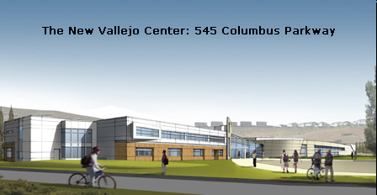
Honor someone you love,
Commemorate your own experience,
Support your alma mater.

 |  |  | 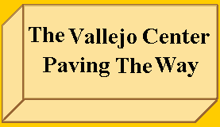
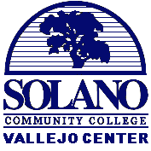  FLAG POLE PATIO  The Paving The Way Brick Campaign offers you the opportunity to become a permanent part of Solano Community College history and to commemorate  your experience or the experience of  a loved one forever! | 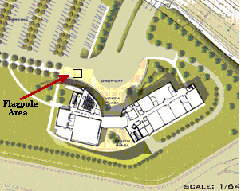  The 10-acre site in the northeast section of Vallejo off Columbus Parkway is a state-of-the-art educational facility. | BUY-A-BRICK  You are cordially invited to become part of the Solano Community  College Vallejo Center; Paving The Way Brick Campaign. Your  personally engraved brick will become a permanent part of the  flagpole patio in the entryway to the new Vallejo Center.  Order online: www.bricksrus.com/order/scc  PayPal, Credit Cards and Electronic Checks accepted!  Or you can order by mail or in person using the form below.  $100 4” x 8” Brick Examples    Up to three lines of lettering, 18 characters per line. Characters include  letters, numbers, spaces, and symbols. (your message will be centered)  (PLEASE USE ALL CAPITAL LETTERS WHERE POSSIBLE)  Ordered by:  Name:___________________________________________________  Address:_________________________________________________  Phone: ________________ Email: ____________________________  THANK YOU!  Please make checks payable to: Solano College Foundation  send to: SCC Foundation 4000 Suisun Valley Road, Fairfield, CA 94534  or stop by the Foundation Office, Building 600/Room 614 (864-7177)  (you can also send or phone in your credit card information if you prefer)
Solano College started in Vallejo in 1945 as Vallejo Junior College. Please help us celebrate our homecoming.

The New Vallejo Center
Is about Dreams, it’s about Opportunity, it’s about You.

For your tax-deductible donation, your brick can be engraved with your name, graduating class or personalized message and will be placed in the front flagpole patio. The finished brick project will welcome all those who come to the Center and will serve to remind current families and visitors alike of Solano College’s rich history and community pride. Your name, or the name of someone you love, will become a permanent part of the Vallejo Campus!

Purchase your brick today to:
• Commemorate your experience at SCC
• Honor a graduate
• Thank a teacher
• Remember a loved one
• Leave a legacy
• Support the Vallejo Center

Thank You for your contribution!

