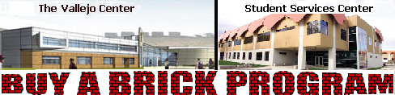 | 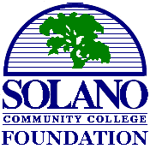

CUSTOM ORDER: GRAPHIC/LOGO BRICK
A final proof will be submitted to you for approval before manufacturing your brick.

PLEASE USE ALL CAPITAL LETTERS FOR BRICK ENGRAVING
Your name/message/logo will be CENTERED IN CAPITAL LETTERS regal blue

8 x 8 Custom Brick: Graphic/Logo Brick with Message: $500.00 donation
Your Image will centered in the top half of the brick with your message which of up to three
(3) lines with eighteen (18) characters (any letter, number, space or punctuation mark) per line.
 | 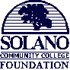  SERVING THE NEEDS  OF STUDENTS AND  EDUCATIONAL PROGRAMS
  Area for Logo or
  Custom Graphic Design
  Approx 7”x3” or 3”x3”
  Line-1: up to 18 characters
  Line-2: up to 18 characters
  Line-3: up to 18 characters

8 x 8 Custom Graphic/Logo Brick: $500.00 donation Graphic design/organizational logo
 | 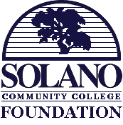
  Area for Logo
  or
  Custom Graphic
  Design
  Approximately 7”x7”

Select Location PLEASE RETURN THIS FORM WITH A COPY OF YOUR IMAGE AND MESSAGE
◻ Vallejo Center RETURN AND MAKE CHECK PAYABLE TO:

◻ Fairfield Campus Solano Community College Foundation
◻ Vacaville Center 4000 Suisun Valley Road Fairfield, CA 94534

Name: ________________________________________ Phone: (_______) _________________________
Address: _______________________________________________________________________________
City: ____________________________________ State: __________________ Zip: __________________
Email Address: ___________________________________________ Amount Donated: ________________

For ordering please call Dr. Charles Shatzer at (707) 864-7177 Fax: (707) 864-7198 EM: charles.shatzer@solano.edu
All donations are tax deductible. The SCC Foundation is a 501(c)(3) nonprofit organization, tax ID: 94-2985584
Thank you for your support and donation.

