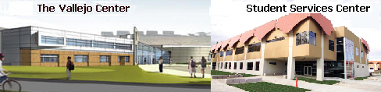  BUY A BRICK PROGRAM | 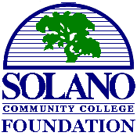

You are cordially invited to become part of the Solano Community College Paving The Way Brick Campaign. Your personally engraved brick will become a permanent part of the entryways of the new Centers. Thank you for your support and donations.

You can order online at www.bricksrus.com/order/scc or use the order form below
- - - - - - - - - - - - - - - - - - - - - - - - - - - - - - - - - - - - - - - - - -

Yes, we’d like to reserve a permanent brick. Please engrave our brick as follows:

PLEASE USE ALL CAPITAL LETTERS FOR BRICK ENGRAVING.
Your name/message will be
CENTERED IN CAPITAL LETTERS.

4 x 8 Brick: $100.00 donation Your message can be up to three (3) lines with eighteen
(18) characters per line. Characters include any letter, number, space or punctuation mark.

8 x 8 Brick: $300.00* donation Your message can be up to six (6) lines with eighteen
(18) characters per line. Characters include any letter, number, space or punctuation mark

PLEASE RETURN THIS FORM AND YOUR CHECK PAYABLE TO:

Select Location Solano Community College Foundation
◻ Vallejo Center 4000 Suisun Valley Road
◻ Fairfield Campus Fairfield, CA 94534
◻ Vacaville Campus

Name: ________________________________________ Phone: (_______) _________________________
Address: _______________________________________________________________________________
City: ____________________________________ State: __________________ Zip: __________________
Email Address: ___________________________________________ Amount Donated: ________________

*Personal/graphic designs and corporate logo 8x8 bricks are available for $500.00. For more information or if you have any questions, please call Dr. Charles Shatzer at (707) 864-7177
All donations are tax deductible. The SCC Foundation is a 501(c)(3) nonprofit organization, tax ID: 94-2985584

