Installation Guide for Mounting Tiles on Floors

Tile Sizes and Shapes
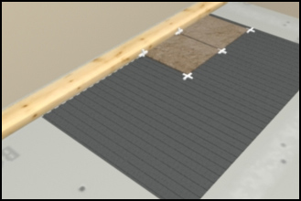
As far as size goes, the most popular tile sold is still the 4 1/4" square wall tile. However, the current trend is towards larger tiles, like 6x6’s, 8x8's, 10x10's and even 12x12's. It's tough for a do-it-yourselfer to install anything bigger than this because the underlayment has to be absolutely even and level.

Tile Types
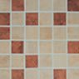
The material that's used to make tile and the methods of manufacturing determine its durability and absorption. It's important to know what tile is best suited for your specific situation.
Most ceramic tile is glazed. Glazed tile is made from a mixture of clays that are pressed into shape. A "glaze" is then applied to the top and baked on. Glazed tiles are available in high-gloss, matte, and abrasive slip-resistant finishes. The glaze on the tile doesn't go all the way through, so if it gets chipped, you're going to see the color inside. Glazed tiles may tend to get scratched on frequently used countertops, but they're ideal for walls. For floors make sure you get a finish that won't be too slippery or show scratches easily.
Quarry tile is a broad classification for any tile made out of a mixture of clays. They are usually deep red in color and left unglazed. These tiles are used mostly for interior floors because they're usually porous. The surface of these tiles can be sealed or left unsealed, although, they may stain if left unsealed.
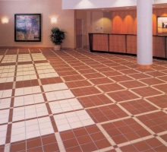
Another trend in high-end tile jobs is natural materials like marble and granite cut into thin pieces and installed like tile.

Choosing Adhesives
The type of adhesive you use depends on where you're tiling, what you're tiling on, and how experienced you are at tiling.
Thinset Adhesives
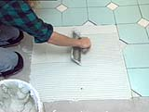
Thinset adhesives come in powder form and must be mixed with either water, liquid latex, or an acrylic additive depending on the type. Thinsets are considered harder to work with because they must be mixed to the right consistency before using.
Thinsets have a stronger bond and are more flexible than organic mastics. They can also support a lot of weight so they're often used for floor installations.
Thinsets can be used in wet areas as well as those exposed to heat.
Organic Mastics
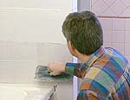
Organic mastics are probably the most commonly used adhesives by do-it-yourselfers. Because they're pre-mixed and ready-to-use, they're considered easier to work with and less time consuming than thinset adhesives.
Mastics are good for setting wall tile because they start gripping the tile even before it's fully cured.
Mastics should not be used in areas that will get wet or will be exposed to extreme heat.
Be aware that if you're using a solvent based mastic the fumes can be potentially explosive and dangerous when inhaled. Always wear a charcoal-filtered mask when working with this, and keep it away from any open flames.

Tools
We've collected pictures and descriptions of the tools used for setting tile. Listed first are the 4 basic tools that you'll need in just about every tile installation:
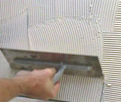
Selecting the Right Tools

Tile Cutter
Tile Nipper
Notched Trowel
Grout Float
And here are 4 specialty tools that aren't required but can make your tile job easier:
Rod Saw
Grind Stone
Tub Saw
Jamb Saw

Tile Cutter
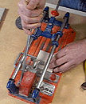
For straight cuts, a tile cutter is the best tool for a do-it-yourselfer. It holds the tile in a frame as you score the cut line with a small wheel. Score it several times if you have a thick tile.
Then as you press down on the handle it snaps the tile at the scored line.
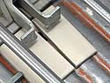
Tile cutters are available at tile supply stores, but it may be best to rent one if you don't plan on doing a lot of tile work in the future.
TIP: Before using a tile cutter, oil the guide bar and scoring wheel. And to keep nice clean cuts replace the scoring wheel as soon as it gets worn.

Tub Saw
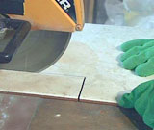
Using a Tub Saw

The tub saw, used mostly by professionals for straight cuts, gives clean, smooth edges. It cuts with a diamond-blade that is bathed in water to keep it cool.
You may want to rent a tub saw if you've got a lot of cuts to make.

Tile Nipper
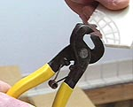
Use a tile nipper for irregular cuts. Score your cut line with a glass cutter or utility knife. Then nibble off small bits of tile until you remove what you need. It helps to score gridlines in the area you want removed. This will help you keep the nibbled pieces small.
Be patient when using a tile nipper, if you take off pieces that are too big you could go beyond your cut line. Then you'll have to start over.
Tile nippers will leave jagged edges on the tile so use them in less visible areas or where you'll be covering it with trim, like around plumbing fixtures.
TIP: Pieces tend to go flying when using a tile nipper so wear eye protection.

Notched Trowel
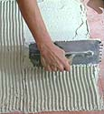
Notched trowels are used to spread and "comb" adhesives onto the underlayment. Two sides of the trowel are notched with either "V" or "square-shaped" notches.
Use a square-notched trowel for setting thinsets on horizontal surfaces. Use v-notched trowels for setting mastics on vertical surfaces.
Trowels also come in different notch depths. Use one that's two-thirds the thickness of the tile you're setting.
If you don't want to invest a lot in trowels, you can get less expensive plastic ones at your tile supply store.
TIP: Another helpful tool for scooping out adhesives and grout, and for spreading adhesives in narrow places is the margin trowel.

Grout Float
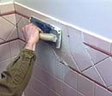
Grout floats are rubber or foam-faced trowels used to force grout into the joints between the tiles. Use sweeping motions diagonally and back and forth to work the grout into the joints.
Once the joints are filled, use the straight edge on the side of the float to scrap the excess grout off the tiles. You need to hold the float almost at a 90 degree angle to do this. Again, diagonal motions work best for this.
As with notched trowels, you can also buy disposable grout floats at your tile supply store.

Rod Saw
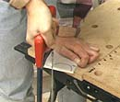
If you're losing patience (and tiles) using a tile nipper for irregular cuts, try a rod saw with a carbide-grit blade. This will take a lot longer than with a tile nipper, but it'll give you a cleaner edge and a more accurate cut.
Option: For perfect circle cuts, like around faucets or supply lines, use a carbide-tipped hole saw bit with your power drill.

Grind Stone
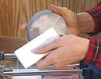
After cutting tile, it's a good idea to smooth the cut edge with a grindstone or tile sander.
Otherwise, you could end up with a sharp edge that may remain partly exposed even after the tile is grouted.
Jamb Saw
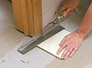
Sometimes it's easier to cut off the bottom of door trim rather than having to cut the tile to fit around it.
Set a jamb saw on top of a tile and piece of cardboard to account for the thickness of the finished floor. Teeth on the side of the saw cut into the jamb.

Floor Underlayment
Because tile is rigid and somewhat brittle, a strong underlayment is the most important part of the tile installation. There are several options for achieving a sturdy floor underlayment.
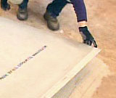
Installing Backerboard

To tile over an existing floor, it must be flat, solid, and well bonded to the sub-floor. The floor and subfloor should be at least 1 1/8" thick for good support.
If your existing flooring is cushioned vinyl or linoleum, you can either remove it or cover it with a proper underlayment. You can install tile over tile as long as it's level and in good condition. You may have to roughen the surface of tile if it's too glossy.
If you have more than one layer of flooring, or if it's damaged beyond repair, it must be removed and another underlayment installed.
WARNING: Some older resilient flooring may contain asbestos fibers. Do not try to remove or sand this type of flooring without having a trained asbestos inspector determine if asbestos is present. Resilient flooring with asbestos can be covered safely with plywood, or removed by a professional contractor.

Concrete Backerboard
For do-it-yourselfers, the best substitute for a mud bed underlayment is concrete backerboard.
Backerboard has a solid concrete core and is faced on both sides with fiberglass and. It can't be damaged by water which makes it ideal for bathroom and kitchen installations.
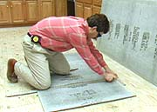
Cutting backerboard is a lot like cutting drywall, except that backerboard is much harder.
Using a framing square, score your cut line a few times. You can use a regular utility knife for this, but you'll go through a lot of blades. A special carbide-blade cutter works better.
TIP: If you're using a utility knife, shorten the blade to keep it from breaking easily.
Break the board by applying pressure until it snaps apart along the score line. You'll probably have to cut through the fiberglass on the back also.
Backerboard is installed much like a plywood subfloor except that you also need to "set" it on to the subfloor using the same type of thinset adhesive (See Choosing Adhesives) that you use to set tiles.
Use the flat side of a notched trowel to spread the thinset out where the sheet of backerboard will be set. Then use the notched side of the trowel to comb out the adhesive. Secure the sheets with galvanized nails about every 8 inches.
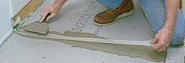
Stagger the joints of the backerboard so they don't line up with one another or fall directly over the joints of the subfloor. Leave about 1/8" space between the sheets of backerboard.
Fill these gaps with tile adhesive using a taping knife. Embed fiberglass joint tape into the adhesive to cover the seams, then cover that with more adhesive. The idea here is to make the joint resemble the material as closely as possible.

Mortar Bed
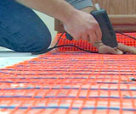
Floor Warming Mat

Professional tile contractors often put down what they call a mortar, or "mud" bed. It consists of a layer of roofing felt, then a wire mesh, then mortar.
A mortar bed is by far the best underlayment for floor tile, but it takes a lot of skill to finish it off level and at just the right thickness. This is the only type of underlayment not recommended for do-it-yourselfers.
If you're having a new floor poured, have it finished with a float that will leave a coarse surface. This is best for a tiling surface. If you already have a smooth-finished floor, rough it up before installing tile.
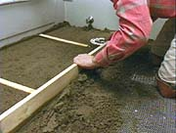
Check to be sure an existing concrete floor is flat. Move a straightedge over the surface and mark high and low spots. Low spots can be filled in with a leveling compound and high spots can be ground down with a rubbing stone or grinder.
TIP: Small cracks in concrete could be caused by the seasonal movement of the slab. To keep these movements from cracking your tile have an isolation membrane installed over the concrete. This is a thin rubber-like material that will protect the tile from the movements of the floor.
If you plan on having a tile floor in your shower, you will need to have a shower pan installed. A shower pan is a waterproof membrane designed to hold water, not just shed it.

This membrane is secured to the mortar bed of a shower with adhesive. It is creased at the corners and is run up the sides of the shower to form a pan. The center of the membrane is cut out for the drain. Another layer of mortar goes over the membrane and is sloped down to the drain.

Floor Layout
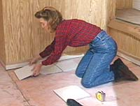
Tile looks best if it's laid out in straight line and square to the walls. That requires a bit of layout prior to installation.
In a perfect world, all walls would be straight and square. Unfortunately this is not usually the case. Everyone will need to evaluate their own circumstances to determine the best layout for their tile floor.

Establishing Reference Lines
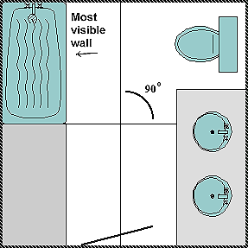
If you have one wall that is definitely more visible than the others, you want your tile to be square to this wall. Snap a chalk line or draw a line out 90 degrees from the center of this wall to the opposite wall.
Next, find the center of this line and draw a line perpendicular to it that runs into the remaining two walls. Double check that these lines are perfectly square; these are your starting reference lines.
If your walls are all equally visible, draw lines between the midpoints of the room's opposing walls. This should give you two perpendicular lines crossing at the center point of the room. These 90 degree reference lines are the key to a good layout.
Testing the Layout
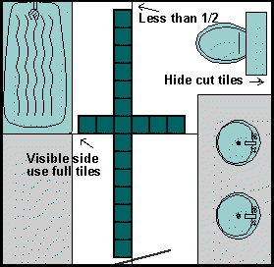
Test-fit a row of tiles along each reference line to see how they lay out. Be sure to account for the thickness of the grout lines.
Check the size of the tiles at the end of the rows. If they end up being less than half their original size you should shift the row either way half a tile's width.
If both ends of a row are visible, you'll want the end tiles to be the same size. If only one end of a row is visible you'll probably want to start there with full tiles. Smaller cut tiles can be hid behind doors or under cabinets.

New Reference Lines
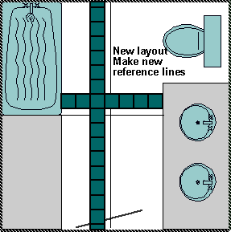
Snap or draw new reference lines to accommodate the adjusted layout. Again, make sure these lines are square.

Laying Out Sections
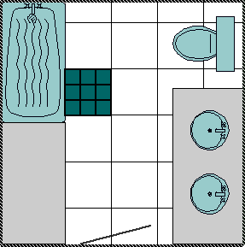
While professional tile setters may only need a couple of reference lines to set tiles evenly, for do-it-yourselfers the more lines the better. Laying out sections, or a grid pattern, will help you keep the tile straight and square. You'll also find that it's easier to work at one small section at a time when setting tile.
From the intersection of your new reference lines, lay out a small section of tiles (about 2 or 3 square feet). Use tile spacers or leave enough room for the grout lines.
Measure this section, then draw a grid of lines across your whole floor based on these measurements. The sections against the walls may not be full sections; this is ok.
TIP: If you're mixing tile colors or shapes, make sure your sections are big enough to include the whole pattern you'll be repeating.
Now you can set your tile one section at a time and maintain your straight lines.

Installing Floor Tile

Once you've established the layout, you can start setting tile. Be sure your floor surface is thoroughly clean of dust and debris.
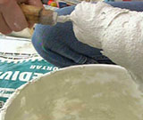
Mixing Thinset Mortar

Prepare only enough tile adhesive to be used within 30 minutes, this will prevent it from drying out.
Set all of your full tiles first, leaving any cut tiles around the perimeter of the room for last.
- Spreading Adhesive
- Setting and Spacing Tile
- Setting Perimeter Tile
- Back Buttering

Spreading Adhesive
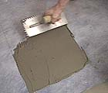
Scoop a glob of adhesive on the floor. Spread it evenly within one section using the straight edge of a notched trowel. Try not to cover up your layout lines, you'll need them to align the tiles.
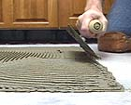
Using the notched edges of the trowel, comb out the adhesive. Hold the trowel at a consistent angle (around 45 degrees) so the top of the adhesive has a uniform height. The pattern of the ridges isn't important. If the adhesive is too dry, the ridges won't comb out evenly; there tend to be gaps. If it's too wet, the ridges won't hold and they'll all blend together.
Again, work right up to the layout lines, but try not to cover them up.

Setting and Spacing Tile
Lay the first tile in a corner, twisting it a little to set it into the adhesive. Test this first tile by prying it up by its corner and looking on the back side. About 70-80 percent of the tile should be covered with adhesive. If you see nothing, the adhesive is too dry. If you see only parallel lines of adhesive, the ridges are too shallow.
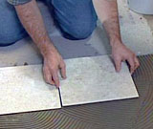
Setting Floor Tile

Set the remaining tiles, aligning them to your outside layout lines. Keeping consistent spacing between the tiles is critical for straight, uniform grout lines.
Some tile are cast with spacing lugs along the edges so you can butt those up and get uniform grout lines. And some tile come pre-mounted on plastic grids so the spacing is already established.
If your tile has neither it's helpful to use plastic spacers. You can find these at most hardware or tile supply stores. Once a section of tile is set you can remove the spacers and reuse them.
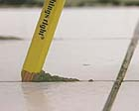
Once the tiles are in place you want to set them into the adhesive and get them all at the same height. You can do this by putting a padded 2x4 across the tile and gently hit it with a hammer. You can also use a rubber mallet or grout float to set the tile.
After setting a section, clean up any mortar that has squeezed up between the tiles. A putty knife or pencil works good for this. Also, sponge off any adhesive on the tile surface.
You should also remove any plastic spacers before they dry in the adhesive.

Setting perimeter Tile
After setting all of your full tiles you can measure, cut and set the tile around the edges. It's a good idea to do these one at a time because the walls may not be square and you'll have to cut each tile a different width.
If you're installing a tile floor that runs longer than 24 feet, or if the floor is near an outside wall or exposed to areas that will expand due to temperature and moisture changes, you will need to account for expansion joints.
Expansion joints are breaks in the tile field that protect and cushion the tile from movements in the underlayment. In most homes, expansion joints can be made by stopping the perimeter tile 1/4 inch from the wall. These should be filled with caulk after the tile are grouted.

Back Buttering
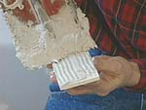
Sometimes you won't be able to trowel the adhesive directly on the floor, like under cabinets or in small areas. That's when you need to "back butter" the tiles individually.
Spread the adhesive on the back of the tile with a notched trowel. If the tile is too small you can also use a margin trowel to spread the adhesive and scratch in notches with the edge of the trowel.
Set the tile giving it a little twist to insure good contact with the underlayment.

Grouting Tile
Once the tile adhesive is dry you can grout the tile. There are two different types of grout: sanded and non-sanded.
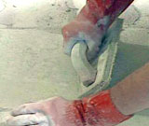
Grouting Tile

Sanded grout has sand added for strength. It's used for joints wider than 1/16 inch, like larger tile on floors.
Non-sanded grout is usually mixed with a latex additive to make it stronger and more workable. It's used for joints less than 1/16 inch wide, like for smaller wall and countertop tiles.
The color of grout you choose can greatly effect the look of your tile. Using a white or a light colored grout highlights the color in tile. Using a light grout with a light tile is good for hiding any mistakes you've made in setting the tile. You should never use a light-colored grout on floors where you get a lot of outdoor traffic because it won't stay that way for long.
Choosing a dark grout with a light tile, or light grout with a dark tile will emphasize the geometric pattern of your layout.
Gray is a good neutral color and it wears well on floors. It also looks good with natural-looking tiles like terra cotta. Before you go wild with a colored grout, test it in a small area first.
Applying Grout

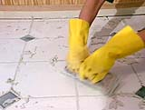
Mix the grout according to the directions with a latex additive.
Use a padded grout float (see Tiling Tools) to spread the grout over a workable section of tile. Push the grout diagonally across the joints to force it down into the gaps.
Grout all the joints except those that you need to allow for expansion joints (see Setting Tile Floors). These would be along fixtures, between the floor and walls, or joints in corners in between walls. These will get sealed with caulk later.
Once the joints are packed with grout, scrap the excess grout off the surface of the tile with the grout float. Hold the float at a sharp angle and again use diagonal strokes to keep from digging grout out of the joints.

Cleaning Off Tile
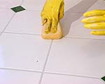
Clean up the excess grout with a damp sponge and a couple buckets of clean water.
First, wipe as much of the grout as you can off the surface of the tiles using circular strokes. Keep rinsing the sponge so it stays clean.
Once the tile surface is clean, make another pass parallel to the grout lines. This is to shape the grout lines in the joints. You want to smooth them down a little below the surface of the tile.
After a while a slight haze will form on the top of the tiles. This can be cleaned off with a sponge or a soft rag. Rub the surface gently because the grout joints may not be completely set yet.

Caulking Tile

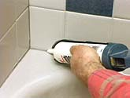
After the grout has had a few days to harden, you should caulk using a clear tub/shower caulk or one in a color that matches the grout.
Caulk in the areas that you allowed for your expansion joints and over joints that may crack because of movement. These areas are between floor tile and a cabinet toekick; between floor and wall tile; and at the inside corner where two walls meet.
Fill the joints completely then smooth them out with a damp rag or your finger.

Sealing Tile and Grout
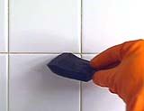
There are two different ways to "seal" tile. You can seal the grout joints and you can seal the tile itself. Which you need to do just depends on the type of tile you have. There are different products for each job.
Your basic glazed ceramic tile will only require the grout joints to be sealed. This will make them more water and mildew resistant, and help keep dirt out of the joints. Most manufacturers suggest you wait a couple of weeks before doing this so the grout has a chance to thoroughly set.
Apply a silicone or water-based grout sealer to the joints. As long as the tile is glazed it's ok if you get some sealer on the tile surface, but you'll need to wipe it off before it dries.
If you're installing a porous material like slate, marble or terra cotta, you should seal the surface of the tiles to prevent them from getting stained with use.
Apply an acrylic top-coat on the tile surface. You'll have to reseal the tile occasionally as it wears off. Don't use any cleaners with ammonia on the tile because it will strip the sealer off.
TIP: Grouting porous tiles like slate, marble or terra cotta may leave grout in the tile causing it to look foggy and dull. To prevent this, seal the tile before you install it with either a top-coat or a pre-sealer. This will keep the grout from penetrating in the pores of the tile.

