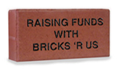



**BRICK FUNDRAISER**

We are raising money to help pay for an addition to our school’s library. The bricks will be placed on the south side library. *Give as much information as possible about the reason for this campaign.*



4x8……… $100

8x8……… $225

EVENT WILL BE HELD ON FRIDAY, APRIL 26TH

IF YOU HAVE ANY QUESTIONS, PLEASE CONTACT JOE SMITH AT (305) 931-7773