

**JOIN US**

IN SUPPORT OF

(LOGO HERE)

YOUR ORGANIZATION NAME HERE

BY BEING PART OF HISTORY & PAVING THE WAY TO A BRIGHTER FUTURE!

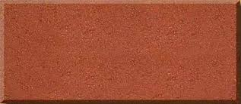

If you have any questions, please call Joe Smith at

(305) 931-7773.

BRICK FUNDRAISING

EVENT

List size of brick(s) and cost of each

**FRIDAY APRIL 25TH**

**6:30PM - 9:30PM**