|  |
| --- |
| **small logo**  **YOUR NAME HERE!** |

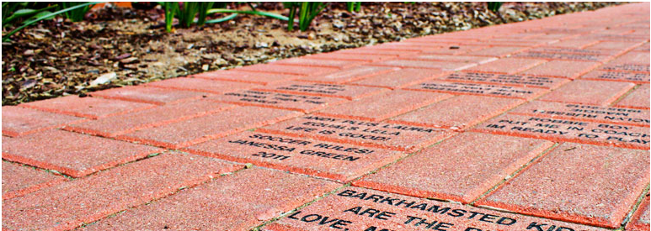

(LOGO HERE)

YOUR ORGANIZATION NAME HERE

**Pave your way to a better future!**

**IF YOU HAVE ANY QUESTIONS, PLEASE CONTACT JOE SMITH AT (305) 931-7773**

**JOIN US ON FRIDAY, APRIL 26th**

**6pm-9pm**